Fish in Microgravity
What are the effects of microgravity on neon tetra?
P.O.U.N.D
Emma Williams, Ryan Elder, Kyle McAnnis, Eric Goessens, Nicholas Cross, Connor Thurman, Matthias Weislogel
1/18/2013

Table of Contents
Introduction 1-2
Method 2-3
Results 4
Conclusion 4-5

Introduction

Originally, our group was going to compete in a competition put on by NASA called “D.I.M.E.”, an acronym that stands for “drops in a microgravity environment”. Unfortunately, the competition was not being held this year; however, we still wanted to follow through with the project of launching neon tetra into a low gravity environment, so we teamed up with Portland State University in order to complete the experiment. We decided that we would study the effects of a microgravity environment upon a living organism, more specifically a fish, and whether or not the fish would try, or even be able, to escape from the fluid. The Dryden Drop tower allows fluid to be released into microgravity for just over two seconds, not giving the fish much time to make its escape. A fluid is always trying to have the lowest possible amount of potential energy, and the fluid achieves this by minimizing its surface area. Thus, when launched into microgravity, the fluid, in our case a drop of water will form a sphere. The sphere of water will have a surface tension of roughly .07 N/m, which is not much to overcome. When the drop of water is released due to the force of gravity that is keeping the drop on the surface that it is resting on being suddenly taken away. This coupled with the drop resting on a hydrophobic surface makes the drop of fluid spring off of the surface that it was previously resting on. However, there is a limit of how large the mass of the fluid can be, as if the fluid gets too large, then it will either barely lift off the surface, or not lift off at all. This is the primary reason that we chose to use neon tetra as our test subjects, as they are quite small, having a maximum size of 3 cm. In addition, neon tetra are known for having skittish personalities, thus we felt that there would be a good chance that they would try to escape from the sphere of water.

Next Page: One of the fish that was able to escape the water.
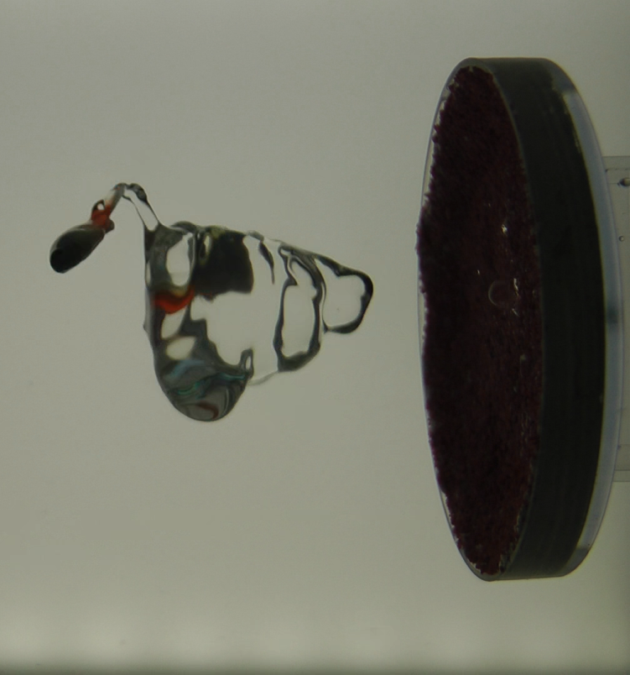
Thus, our research question was: how will a neon tetra react when put in a droplet that is sent into microgravity? Based on the attributes of neon tetra, we predict that the fish will panic and swim out of the droplet while suspended in microgravity. Our independent variable will be the number of fish inside a droplet, our dependent variable will be whether or not the fish escape, and our control will be the volume of the water.

Method
We constructed the device to contain the fish in such a way that would allow us to both see the movement of the fish clearly, while providing it with the chance to survive. We had a sealed, clear container, in which we taped down a box with a removable top, so we could secure the hydrophobic platform while also being able to remove it in order to re-apply Mars Sand. The platform was a small bowl that we taped to the removable top and covered in putty that would hold onto the Mars Sand. Mars Sand was used because it is a hydrophobic material that helps the water droplet shoot high into the air when the contraption is sent into microgravity. We then filled the rest of the container with water to try and help the fish survive the experimentation process (and none were harmed during the experiment). Lastly, there was a back lit panel that allowed us to have high definition video footage of the drop.
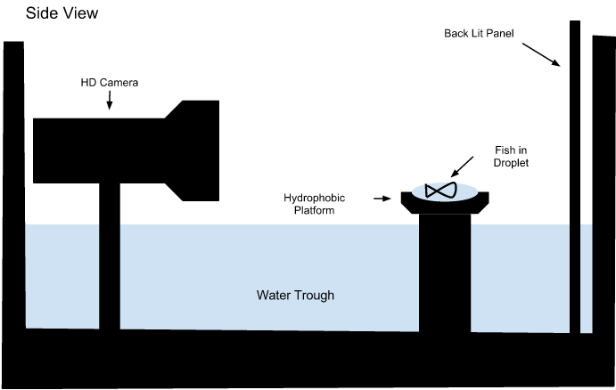
Diagram of the setup

In order to get the fish from the fishbowl to the platform, we poured 10mL of water into a beaker, then put either one or two fish into the beaker. The beaker was then quickly taken to the tower, and the fish and water were poured onto the platform, ready to be dropped. Once the fish was on the platform, the door to the drag shield was put on, and the whole compartment was dropped 31.1 meters, sending the water into low-g for 2.13 seconds.
Materials used:
- Dryden Drop Tower
- Mars Sand
- Precision Wipes
- Putty
- Duct Tape
- Video Camera
- Video Camera Mount
- Water
- Box w/Removable Top
- Neon Tetra (25)
- Small Bowl-like Object
- Back-light
- Large, Clear Box
Results

Volume of sphere = (4/3)πr³
V = 10 ml r = 1.33 cm

Diameter of Drop  (± .05 cm) | Final Distance  (± .1 cm) | Total Distance  (± .1 cm) | Seconds Traveled  (± .05 s) | Speed of Drop  (± .1 cm/s)
2.66 | 6.0 | 3.34 | 2.1 | 1.59

Drop 2 Calculations (calculation of the acceleration of the fish that exited the drop):
Distance Fish Traveled: .022 m in .2 seconds
Velocity = Distance / Time Velocity of the fish = .11 m/s
Assuming the initial velocity at the beginning of that time period was 0 m/s
Acceleration = (V_{f} – V_{i}) / Time a = (.11 – 0)/.2
A = .55 m/s²
(78 Degrees Fahrenheit - 32) x 5/9 = 25.5556 Degrees Celsius
Surface Tension (N/m) = - 0.00017 x Degrees Celsius + 0.0761
-0.00017 x 25.5556 + 0.0761 = 0.0718 N/m

We conducted a total of 7 tests. Of those tests, only 6 were able to launch from the hydrophobic pad that we had set in on. Three fish succeeded in escaping out of a total of 10 fish.
Conclusion
We discovered that the majority of our fish were unable to escape from the water droplets. A total of 7 droplets were successfully launched containing a total of 10 fish. However, out of those 10 fish, only 3 were able to escape the droplet. This disproves our hypothesis which stated that we predicted that the fish would panic and escape. The reasons behind the results combine both biology and physics. First we will affect the biological reasons. Judging by the fact that the fish moved, it was obvious that the fish could feel the decrease in gravity despite their shared density with the water. However, that change in gravity and the backlight that we used to improve the quality of our videos caused some of the fish to shut down rather than go into a panic. The physics reasons primarily concern surface tension. According to our calculations, the surface tension of water at 78 degrees Fahrenheit is .0718 N/m. Most of the fish that were still able to move were unable to generate enough force to overcome that surface tension.
While we were able to gain use of a high quality drop tower, there were many factors that could have led to changes in data. The temperature of the water that was used to calculate the surface tension is inaccurate as a result of the time in between the removal of the fish from the holding tank and the dropping of the package. In order to correct it, it would be necessary to manipulate the heat of the drop package in order to maintain a constant temperature. Another factor is the amount of test samples that we used. In order to determine a common behavior for a species, it is necessary to test more subjects that we were able to. However, we were limited by time. In future experiments, it would be wise to use as many fish as possible in order to obtain a better picture. It would also be beneficial to measure the mass of each fish in order to determine how much momentum each fish is able to generate. Then it would be possible to compare the force that an average neon tetra generates with the surface tension of water. There are a variety of other ways to manipulate the data such as doing more tests with different amounts of fish and looking for patterns and manipulating the temperature of the water.

There is a great amount of uncertainty in the calculation of the acceleration, as in order to get the distance traveled, the distance was measured on a computer screen. The calculation of the radius was double-checked by the measuring of the computer screen, and the radius that was measured on the screen was quite close to the calculated radius.
Surface Tension. University of Sydney, Australia, n.d. Web. 17 Jan. 2013. <http://www.physics.usyd.edu.au/teach_res/jp/fluids/surface.pdf>.
Haworth, Joe. "Neon Tetra Facts by Joe Haworth." ArticleCitycom RSS. N.p., n.d. Web. 13 Jan. 2013. <http://www.articlecity.com/articles/pets_and_animals/article_2242.shtml>.

